Access Information Statement (March 2019). The information below aims to accurately describe facilities and services we have here at:-
Hillcroft Park, Pooley Bridge.

This site is on a natural fell side within the Lake District National Park. It is a large site with some steeply sloping contours. Some of the pitches are located on partially level land. The roads are joint vehicular and pedestrian use, approximately 3m wide, with some steeply sloped sections. There are speed bumps across the park. Lighting is by way of bulkhead lighting to the buildings along with roadside lights to a height of 1.5m

Contact Information

For those wishing to contact Hillcroft Park by phone, please call 017684 86363. There is an answering machine for calls outside of Office Hours, or if all the lines are busy. Additional information can be gained from the web-site, www.hillcroftpark.co.uk

Arrival and Parking facilities

There is a mainline railway station at Penrith and the local Stagecoach bus service 508 from Penrith stops in Pooley Bridge. Hillcroft Park is a 5-10 minute walk away.

This site is on a steep hillside location with some wooded areas, with various level sections. Entry to the site is by a tarmac drive on a hillside, leading to an open area in front of reception. From here there is an ornate wrought iron gate, operated by a numeric coded pad at a height of 0.90m, accessible to most drivers. The exit barrier is automatic.
Visitor parking is to the right hand side of the open area, providing four marked parking bays, none specifically identified for disabled people. Disabled parking is permitted directly outside of the reception, although not marked. Late arrivals/overnight parking is shared with visitor parking. It is also possible to park immediately in front of the Reception, for those arriving and checking in, giving again a short travel distance for those with limited mobility.
The visitor parking area is approximately 5m from reception.
Lighting is from lights on the corner of the reception building.
All holiday home accommodation has its own adjacent designated parking space for one car in some cases two.

Reception

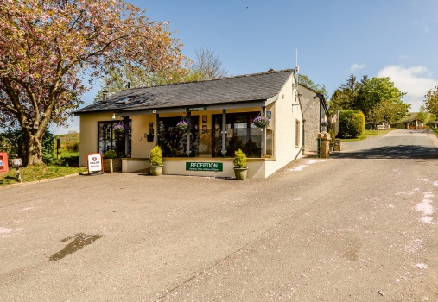

The Reception is located at the entrance to the Park and is accessed by a ramp. The ramp is approximately 3m in length and 1.065m wide, with a gradient approximately 1:13. There are toughened glass panels on the outer side of the ramp.
The inward-opening door to reception has a 0.87m clear opening width, with toughened safety glass full length panel and a clearly identified handle at 1m high.

Internally, there is ample space for wheelchair users and seating. The counter is 1.12m high with access to a lower section of the counter to the side. There is no hearing enhancement system. The floor is a solid wood laminate and there is reasonable visual contrast. Lighting is provided by flush fitting ceiling lights.

Shop

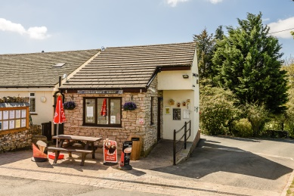

The shop is also located at the entrance of the Park. It is accessed by a small ramp (1m) and has an inward-opening door with a small step (50mm) to get over. The door has a clear opening width of 0.75m, with toughened safety glass full length panel and clearly identified handle at 1m high. There is plenty of internal space. There is a counter in the shop at a height of 0.92.

Holiday Homes and Lodges

The Holiday Homes and Lodges that are on the Park are mostly privately owned with 19 and 2 Cottages owned directly by the Park and 8 privately owned used to hire out. Due to the gradient of the park and internal layouts, the accommodations do not have the easiest access for wheelchair users. The Portland and Retreat would be the best for those with less mobility, but not completely wheelchair friendly. This is an issue that the Owners are aware of and are working towards a solution. The layout of the Park provides a tiered effect, with each row of Holiday Homes at a higher level than the row directly in front.

Hot Tubs

Hot tubs are available to hire with the following accommodation;
Meadowbank Cottage
Meadowcroft Cottage
Both of the Clearwater Lodges
The Retreat Lodge
The Jasmine Lodge
Meridian Lodge

Atlanta Holiday Homes

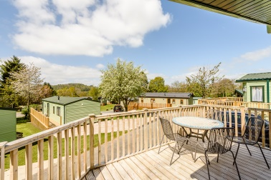

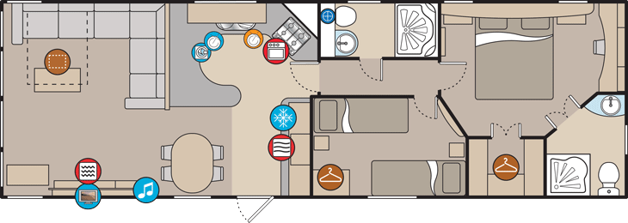

The two Atlanta’s which are Pet Friendlyare approximately 120m from the Reception. Each of the Atlanta’s has wooden decking with 3 steps up to Atlanta 25, and 2 steps up to Atlanta 16, with ample parking for a family car adjacent to each Holiday Home. The following details are the same for each of the Atlanta Holiday Homes:
- The entrance door has an opening width of 0.725m with a green double glazed door with a full length toughened glass panel and matching green handle at a height of 1.00m.
- You then enter into an open plan Kitchen/Dinning/Lounge area.
- The Kitchen worktops are 0.900m high with Cupboards, a fridge/freezer, dishwasher and oven and grill built in below it. A gas hob sits at the same height as the worktops. The Microwave is positioned approximately 0.5m above the worktop in a separate housing between some of the wall mounted kitchen cupboards.
- Internally all the cupboard and door handles are a contrasting colour to make them stand out.
- All the chrome finished light switches are at a height of 1.4m and the electrical outlets are either just above the worktops in the kitchen or at a height of 0.25m throughout the rest of the Holiday Home.
- In the Lounge there are Patio Doors, which open to a width of 1.790m out onto the wooden decking. Internally the handles and doors are white, externally they are both green. There is a TV on the wall above the fireplace.
- From the Kitchen there is a Hallway with a width of 0.65m leading to 2 bedrooms and a family shower room. The Hallway door has an opening width of 0.570m.
- The Family Shower Room door has an opening width of 0.51m and leads into a modern design room consisting of a standard W/C and Wash Basin and a shower cubicle measuring 1.00m x 0.73m. The cubicle door is of a bi-folding design and has an opening width of 0.9m.
- The twin bedroom has a door opening width of 0.51m and contains 2 x 2’6” wide single beds, a small bedside cabinet and a large double wardrobe.
- The Main Bedroom has a door opening of 0.56m and contains a King-size bed. There is a walk-in wardrobe with a 0.6m clear opening, an en-suite with a standard W/C, washbasin and a shower cubicle. The shower cubicle has an opening width of 0.56m. There is a vanity unit in the Main Bedroom at a height of 0.70m with knee room below it.
- All the floor coverings are a contrasting colour to the walls

Meridian Lodge

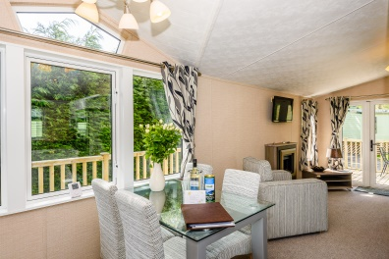

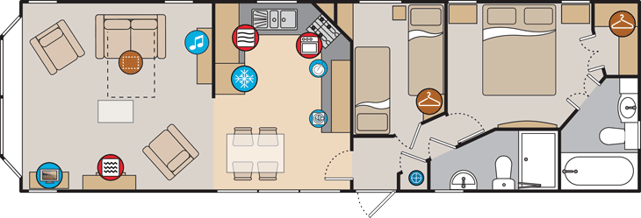

The Meridian Lodge is approximately 150m from the Reception. It has wooden decking with 1 step up to it and ample parking for a family car at the rear of the unit. This accommodation is pet friendly and has a Hot Tub.
- The entrance door has an opening width of 0.625m with a green double glazed door with a full length toughened glass panel and black handles at a height of 1.03m.
- You then enter into hallway including the boiler cupboard and doors leading to the family bathroom and the 2 bedrooms.
- Turning left you will enter into the Kitchen where the worktops are 0.900m high with Cupboards, a fridge/freezer and a dishwasher built in below it. A gas hob sits at the same height as the worktops. The Microwave is positioned approximately 1.26m above the floor and sits above the mid-level oven and grill. The high level kitchen units are 0.04m above the worktop.
- Internally all the cupboard doors are a high gloss white finish and have chrome, contrasting handles.
- All the chrome finished light switches are at a height of 1.4m and the electrical outlets are either just above the worktops in the kitchen or at a height of 0.25m throughout the rest of the Holiday Home.
- In the Lounge there are Patio Doors, which open to a width of 1.13m out onto the decking (2.99m x 5.00m). Internally the doors are white with black handles.
- The lounge also includes a modern 2 seater settee and 2 x armchairs, a wall mounted TV (1.40m) located above an electric fire.
- The dining table, adjacent to the kitchen area, is a standard height and has a toughened glass top and silver metal legs and comes complete with 4 dining chairs.
- The hallway has a width of 0.70m leading to 2 bedrooms and a family shower room. The Hallway door has an opening width of 0.670m.
- The Family Shower Room door has an opening width of 0.53m and leads into a modern design room consisting of a standard W/C and Wash Basin and a shower cubicle measuring 1.00m x 0.73m. The cubicle door is of a bi-folding design and has an opening width of 0.9m.
- The twin bedroom has a door opening width of 0.53m and contains 2 x 2’4” wide single beds, a small bedside cabinet, a wardrobe and a vanity unit with 4 drawers and a mirror.
- The Main Bedroom has a door opening of 0.51m and contains a King-size bed and wall mounted TV. There is a walk-in wardrobe with a 0.56m clear opening, an en-suite with a standard W/C, washbasin and bath, incorporating an adjustable height shower at the end where the taps are.
- All the floor coverings are a contrasting colour to the wall.
Holicombe, Tamarack Lodge and Hillcroft Lodges.

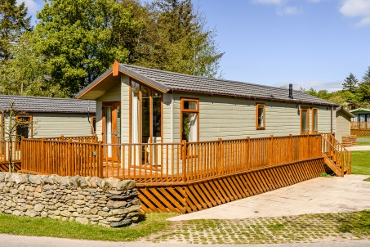

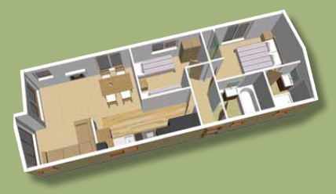

These Lodges have ample parking spaces adjacent to each Lodge. Access is via a couple of steps onto a wooden decking, which extends down the door side and along the front. Some of these Lodges are Pet Friendly. All the lodges have the following characteristics:
- The main door is half glass and half panel, in brown UPVc with chrome handles at a height of 1.00m and an opening width of 0.76m. This leads into a hallway of 0.96m wide.
- All the light switches are at a height of 1.40m and the electric sockets are either above the kitchen worktop or at a height of 0.45m from the floor.
- From the hallway there are doors of 0.57m width leading to two bedrooms and a family bathroom. The hallway is 0.96m wide.
- All the doorways are 0.57m wide unless stated otherwise and have contrasting handles.
- The family bathroom includes ample space and a modern, standard size W/C and hand basin. The bath sides are 0.56m high and incorporate an over the bath shower and shower screen. The shaving point is 1.40m high and the light switch is 1.11m high on the wall in the hallway.
- The main bedroom has a double bed and vanity unit (0.80m). There is an en-suite (doorway 0.52m) including a half round shower (0.40m opening) W/C and hand basin. The shaving point is 1.40m high and the light switch is 1.11m high on the wall in the bedroom. There are overhead lockers (1.65m) above the bed and a double wardrobe with drawers at the bottom for storage.
- The twin bedroom contains 2 x 3’ single beds and a single wardrobe. There are overhead lockers (1.65m) above the beds.
- The Kitchen/Dinning/Lounge area is an open plan layout with Patio doors (1.250 opening width) leading out onto the decking at the front. There is a wall mounted TV above the fire place.
- The kitchen includes a worktop at a height of 0.90m with built in units. There is an upright fridge/freezer, dishwasher and under counter oven and grill. The hob sits at the same height as the worktops. The microwave is 0.53m above the worktops in its own housing.
- All the floor coverings are a contrasting colour to the walls.

Aspen

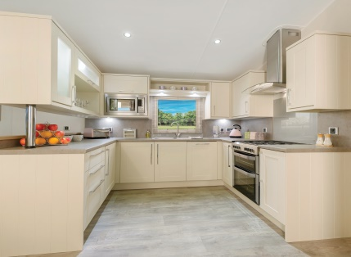

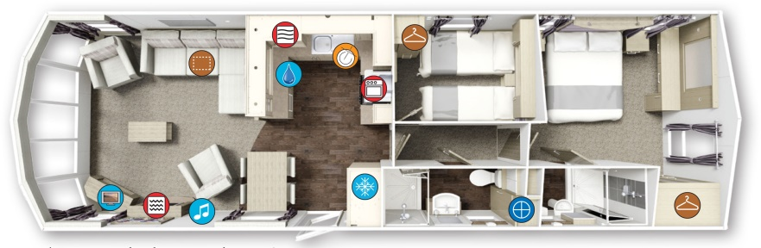

The Aspen has wooden decking across the front and extends along the side to the side door and has 3 steps up onto the wooden decking area, with ample parking for a family car adjacent.
• The entrance door has an opening width of 0.725m with a green double glazed door with a full length toughened glass panel and black handle at a height of 1.00m.
• You then enter into an open plan Kitchen/Dinning/Lounge area with a cloak cupboard and an integrated 70/30 fridge freezer immediately on the right.
• The Kitchen worktops are 0.900m high with Cupboards, dishwasher and oven and grill below it. A gas hob sits at the same height as the worktops. The Microwave is positioned approximately 0.5m above the worktop in a separate housing at the same height above the worktop as the wall mounted kitchen cupboards.
• Internally all the cupboard and door handles are a contrasting colour to make them stand out.
• All the light switches are at a height of 1.4m from the floor and the electrical outlets are either just above the worktops in the kitchen or at a height of 0.25m throughout the rest of the Holiday Home.
• In the Lounge there are Sliding Outlook Doors, which open to a width of 1.32m onto the decking. Internally the handles are black and doors are white, externally the doors are green and the handles are black. There is a TV on a low cabinet.
• From the Kitchen there is a Hallway with a width of 0.65m leading to 2 bedrooms and a family shower room. The Hallway door has an opening width of 0.570m.
• The Family Shower Room door has an opening width of 0.51m and leads into a modern design room consisting of a standard W/C and Wash Basin and a shower cubicle measuring 1.00m x 0.73m. The cubicle door is of a bi-folding design and has an opening width of 0.75m.
• The twin bedroom has a door opening width of 0.51m and contains 1 x 2’6” and 1 x 3’ wide single beds, a small bedside cabinet and a single wardrobe with 3 drawers below.
• The Main Bedroom has a door opening of 0.57m and contains a King-size bed. There is a wardrobe at the end of the bedroom, an en-suite with a standard W/C, washbasin and a shower cubicle. The shower cubicle has an opening width of 0.75m. There is a dressing table in the Main Bedroom at a height of 0.70m with knee room below it.
• All the floor coverings are a contrasting colour to the walls.

Retreat Lodge.

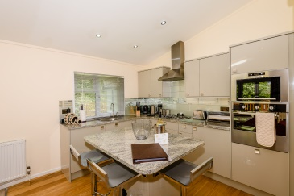

The Retreat is situated approximately 90m uphill from the Reception. It is easily accessible and has 4 steps up onto the wooden decking area. The parking area is to the rear of the lodge. The decking area is down the side of the Lodge and extends along the full width of the Lodge at the front where the hot tub is located.
- The entrance door is of brown UPVc construction with 2 toughened glass panels and an opening width of 0.73m. The handle is contrasting chrome and is 1.04m off the decking. There is a small step up of 0.10m from the decking into a small porch area in front of the door.
- You then enter into a hallway with a light oak wooden floor and beige carpets, which leads to the bedrooms.
- Turning to the left, you enter into a very modern style open plan kitchen/diner/lounge area with flush fitting ceiling lights. The lounge / dining area has a beige carpet covering the floor.
- The Lounge contains 2 chairs and a matching “L” shaped sofa. There is a wall mounted TV above the fire surround and electric fire.
- There is a bi-fold patio door on the front of the Lodge with an opening of 1.65m when fully opened.
- The dining area contains a large grey wooden table and 4 chairs.
- The kitchen has granite effect worktops at 0.9m with cupboards, dishwasher and an integrated fridge freezer. The microwave is housed at eyelevel and sits above the mid height oven. There is a stainless steel sink set into the worktop. A gas hob sits at the same height as the worktops The cupboard doors are fitted with contrasting chrome handles. The floor is covered with Lino.
- In the centre if the kitchen area id a 1.1m² island unit with a drinks chiller cabinet and bottle racks below it.
- All the light switches are at a height of 1.39m and the electrical sockets are 0.15m off the floor (except in the kitchen, where they are situated .015m above the work surface).
- Off the kitchen there is a 0.57m wide doorway leading to the hallway. Above this door is the Co2 detector. The hallway leads to the family shower room and the 2 bedrooms. There is also a smoke detector in the hallway. All the doors are a light wooden effect with contrasting chrome handles at a height of 0.88m.
- The family bathroom has a doorway of 0.56m and modern style fittings (W/C & Basin). The bath has a toughened glass shower screen. The shower head height is adjustable. The walls and floor are fully tiled.
- The Main Bedroom has a door opening of 0.66m and contains a double bed. At the bottom of the bed is a wall mounted TV at a height of 1.82m, below which is a vanity mirror and a double electric socket. There is a double wardrobe with mirrored doors containing shelves and hanging rails. The en-suite (0.57m opening) with a standard W/C, washbasin and a walk in shower. The shower head height is adjustable. All of the en-suite is tiled
- The twin bedrooms contain 2 x 3’ single beds, mirrored wardrobes, drawers and a wall mounted TV.

Meadowbank Cottage.

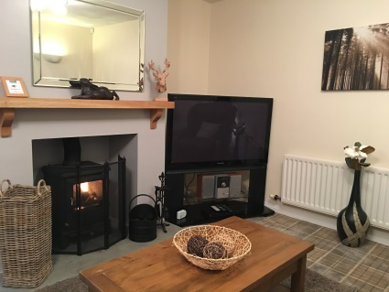

This 2 bedroom Single Storey Cottage is located at the entrance to the Park and is 15m from the Shop and 25m from the Reception. The separate parking area is level and adjacent to the entrance door. This property also has a Hot Tub.
- The entrance door has a small 0.025m step and an opening width of 0.700m, which leads into a small hallway and utility room.
- The utility room includes a Washing Machine, Ironing Board and Iron. There is a worktop above the Washing machine at a height of 1.00m.
- All the light switches are at a height of 1.17m and the electrical sockets are 0.60m off the floor (except in the kitchen, where they are situated above the work surface).
- The modern and well equipped kitchen/dining area have work surfaces at a height of 0.92m with cupboards and an oven directly below. The microwave stands directly on the work surface and there is a free standing fridge/freezer and dishwasher in close proximity.
- The kitchen/diner leads through to a spacious lounge area with views over towards Lake Ullswater and has the benefit of a Log Burning Stove and freestanding TV in the corner.
- The open plan hallway leads to the 2 bedrooms and the family Bathroom.
- The bathroom contains a modern style suite with an adjustable height shower over the bath which has sides at 0.60m. The shaving point is 1.48m high.
- The main bedroom is spacious and includes a 5’ bed, wardrobes, chest of drawers and an occasional chair. There is a cabinet at either side of the bed, with a light on and also a wall mounted TV.
- The twin bedroom is rather large and has 2 x 3’ single beds, wardrobes and a set of drawers.

Meadowcroft Cottage.

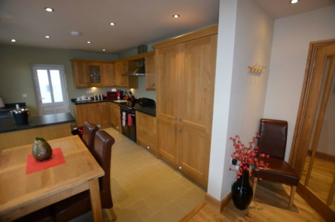

This 3 bedroom single storey Cottage is located at the entrance to the Park and is adjacent to the Shop and 25m from the Reception. The separate parking area is level and adjacent to the front entrance door. This property has a Hot Tub.
- Access to the front entrance door is via 3 x 0.150m steps leading onto a patio area and then a further 3 x 0.150m steps up to the main entrance door. This is of a white UPVc construction with 2 double glazed panels and a contrasting handle at a height of 1.05m. The door has an opening width of 0.700m, which leads into a small hallway and open plan kitchen.
- All the floors, unless otherwise stated, are of a solid oak board construction.
- All the light switches are at a height of 1.12m and the electrical sockets are 0.43m off the floor (except in the kitchen, where they are situated above the work surface). All the internal doors are of a Solid Oak construction with contrasting handles at a height of 1.00m
- The modern and well equipped kitchen/dining area has a black tiled floor with under floor heating and black work surfaces at a height of 0.92m, which contrast with Solid Oak cupboard doors the built in Range style oven . There is a large fridge/freezer, a dishwasher, Wine Chiller cabinet and separate washing machine and dryer all built into the kitchen units. The wall units are 0.043m above the work surface.
- The kitchen/diner also has an Oak Dining table and Chairs with a wall mounted TV.
- There is a white UPVc constructed side exit door (0.65m opening) leading from the kitchen into an external open passage (1.05m wide) with 2 x 0.170m steps. This provides access towards the Reception and the rest of the Park.
- The spacious Lounge has a wall mounted 55” TV and Wood Burning Stove. There is a 3 and a 2 seater sofa and an arm chair. The double doorway into the lounge which can open up to 1.460m wide.
- The open plan entrance hallway leads to the hallway to the bedrooms and the bathroom. The door opening is 0.720m wide.
- The bathroom contains a modern style suite in classic white with chrome fittings, with contrasting black quartz style flooring with under floor heating and vanity unit tops (0.85m), a freestanding bath and walk in shower. The shower cubicle measures 1.58m x 0.87m and has an entrance opening of 0.620m. The bathroom sink is housed within the vanity unit. There is also a wall mounted TV in the bathroom (1.57m). There are wall mounted storage cupboards and a large mirror 0.51m above the vanity units. Contained within the left-hand side cupboard is the shaving point (1.60m). The doorway into the bathroom has an opening width of 0.72m.
- The main bedroom is spacious and includes a 5’ divan bed, wardrobes and a chest of drawers. There is a cabinet at either side of the bed, with a light on. The doorway into the bedroom has an opening width of 0.72m. There is a wall mounted 42” TV.
- The twin bedroom is rather large and has 2 x 3’ single divan beds and a walk in wardrobe. The doorway into the bedroom has an opening width of 0.74m.
- The spacious double bedroom includes a 4’6” divan bed, a walk in wardrobe and a mirrored set of drawers (0.85m). The doorway into the bedroom has an opening width of 0.72m.

Jasmine Lodge

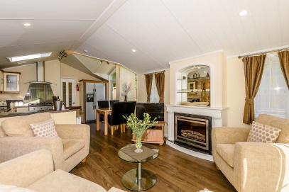

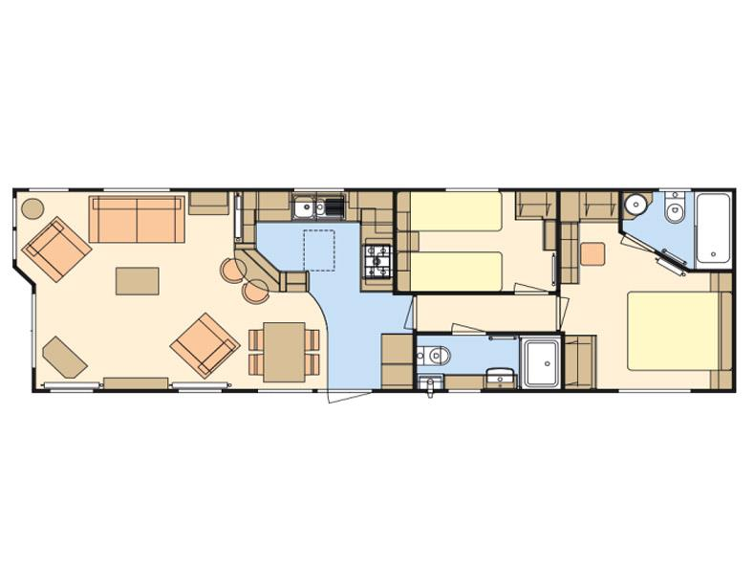

The Jasmine lodge is situated approximately 100m uphill from the Reception. It is on one of the more easily accessible sites and has only one step up onto the wooden decking area. The parking area is to the front left-hand side of the lodge. The Jasmine is Pet Friendly with a Hot Tub.
- The entrance door is of green UPVc construction with a toughened glass full length panel and an opening width of 0.73m. The handle is a contrasting chrome design and is 1.00m off the decking.
- You come into a very modern style open plan kitchen/diner/lounge area.
- The kitchen has worktops at 0.91m with cupboards, dishwasher and an oven below. The microwave is 0.61m above the worktop. A gas hob sits at the same height as the worktops. There is also a large upright freestanding fridge/freezer.
- The lounge has a two seater sofa and two easy chairs the TV is on a low cabinet beside the fire.
- All the light switches are at a height of 1.29m and the electrical sockets are 0.15m off the floor (except in the kitchen, where they are situated above the work surface).
- Off the kitchen there is a 0.57m doorway leading to a 0.68m wide hallway. The hallway leads to the family shower room and the 2 bedrooms.
- The family shower room has a doorway of 0.59m and modern style fittings (W/C & Basin). The shower cubicle is 1.19m x 0.70m with an opening of 0.46m. The shower head height is adjustable.
- The Main Bedroom has a door opening of 0.57m and contains a King-size bed. There is a wardrobe, sets of drawers, an en-suite (0.58m opening) with a standard W/C, washbasin and a shower over a bath with sides of 0.58m. The shower head height is adjustable. There is a vanity unit in the Main Bedroom at a height of 0.78m with knee room below it. There are overhead lockers (1.48m) above the beds, there is also a wall mounted TV.
- The twin bedroom contains 2 x 2’6” single beds and a single wardrobe and drawers. There are overhead lockers (1.48m) above the beds.

Clearwater Lodges

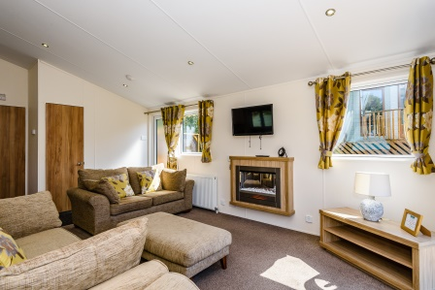

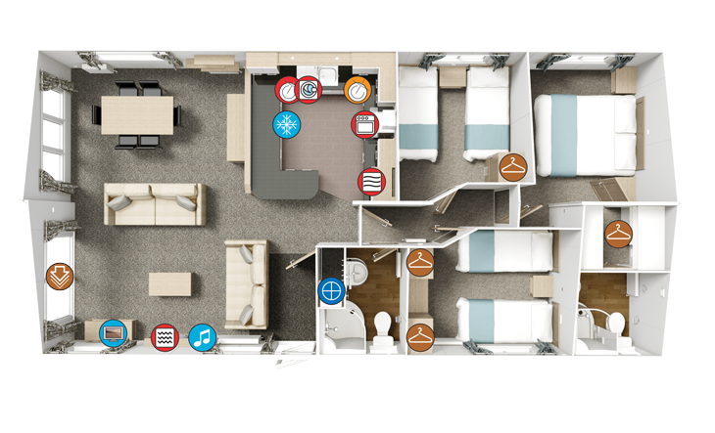

There are 2 Clearwater 3 bedroom Lodges, Clearwater 11 and Clearwater 12. Both units are as described below, except for the Clearwater 12, which has a bath rather than a shower in the family bathroom. Both these lodges have Hot Tubs.

Both lodges are situated approximately 100m uphill from the Reception. They are both easily accessible and have only one step up onto the wooden decking area. The parking area is to the right-hand side of the lodge. The decking area is across the front of the Lodge and extends down the door side to the rear where there is a Hot Tub located.
- The entrance door is of green UPVc construction with a toughened glass full length panel and an opening width of 0.73m. The handle is contrasting black and is 1.04m off the decking.
- You enter into a very modern style open plan kitchen/diner/lounge area with flush fitting ceiling lights. There is an area inside the doorway that has a heavy-duty black carpet. The remainder of the lounge / dining area has a brown/beige carpet covering the floor
- The Lounge contains 2 sofas, a matching chair and foot stool. There is a wall mounted TV above the fire surround and electric fire. To the left of the fire surround is a control unit for the Bluetooth MP3 system (0.87m).
- There is a sliding patio door on the front of the Lodge with an opening of 0.76m.
- The dining area contains a large light oak effect table and 6 leather effect chairs.
- The kitchen has black granite effect worktops at 0.9m with cupboards, dishwasher, integrated fridge freezer and a washing machine below. The microwave is housed 0.45m above the worktop at the same height as the wall cupboards. There is a stainless steel sink set into the worktop. A gas hob sits at the same height as the worktops. The cupboard doors have a cream high gloss finish with chrome handles. The floor is covered with wood effect Lino.
- All the light switches are at a height of 1.39m and the electrical sockets are 0.15m off the floor (except in the kitchen, where they are situated .015m above the work surface).
- Off the kitchen there is a 0.57m wide doorway leading to the hallway. Above this door is the Co2 detector. The hallway leads to the family shower room and the 3 bedrooms. There is also another Co2 detector in the hallway. All the doors are a light wooden effect with contrasting chrome handles at a height of 0.88m.
- The family shower room has a doorway of 0.56m and modern style fittings (W/C & Basin). The shower cubicle is curved and has an opening width of 0.43m. The shower head height is adjustable.
- One of the Clearwater Lodges has a Bath in, rather than the shower cubicle. The bath height is 0.57m and has a shower over the bath with a clear shower screen. The shower head height is adjustable.
- The Main Bedroom has a door opening of 0.66m and contains a King-size bed. At the bottom of the bed is a wall mounted TV at a height of 1.82m, below which is a vanity mirror and a single electric socket. There is a door (0.57m) leading into a walk through wardrobe containing drawers, shelves and hanging rails. This then leads into an en-suite (0.57m opening) with a standard W/C, washbasin and another curved, corner shower as per the main bathroom. The shower head height is adjustable.
- Both twin bedrooms contain 2 x 3’ single beds, wardrobes and drawers.

Sheraton Holiday Homes

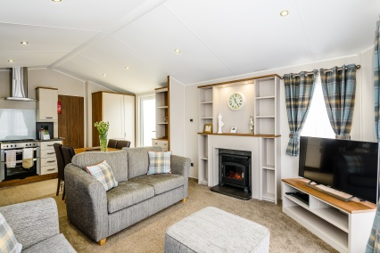

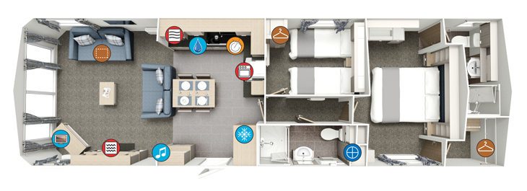

There are currently 4 Willerby Sheraton Holiday Homes. The Sheratons are approximately 120m from the Reception. Each of the Sheratons has wooden decking across the front and extends along the side to the side door. The Sheratons have either 2 or 3 steps up onto the decking area, with ample parking for a family car adjacent/or in front of each Holiday Home. The following details are the same for each of the Sheraton Holiday Homes:
• The entrance door has an opening width of 0.725m with a green double glazed door with a full length toughened glass panel and black handle at a height of 1.00m.
• You then enter into an open plan Kitchen/Dinning/Lounge area with a cloak cupboard and an integrated 70/30 fridge freezer immediately on the right.
• The Kitchen worktops are 0.900m high with Cupboards, dishwasher and oven and grill below it. A gas hob sits at the same height as the worktops. The Microwave is positioned approximately 0.5m above the worktop in a separate housing at the same height above the worktop as the wall mounted kitchen cupboards.
• Internally all the cupboard and door handles are a contrasting colour to make them stand out.
• All the light switches are at a height of 1.4m from the floor and the electrical outlets are either just above the worktops in the kitchen or at a height of 0.25m throughout the rest of the Holiday Home.
• In the Lounge there are Outlook Doors, which open to a width of 1.32m out onto the decking. Internally the handles are black and doors are white, externally the doors are green and the handles are black. The TV in on a low cabinet in the lounge
• From the Kitchen there is a Hallway with a width of 0.65m leading to 2 bedrooms and a family shower room. The Hallway door has an opening width of 0.570m.
• The Family Shower Room door has an opening width of 0.51m and leads into a modern design room consisting of a standard W/C and Wash Basin and a shower cubicle measuring 1.00m x 0.73m. The cubicle door is of a bi-folding design and has an opening width of 0.75m.
• The twin bedroom has a door opening width of 0.51m and contains 2 x 2’6” wide single beds, a small bedside cabinet and a single wardrobe with 3 drawers below.
• The Main Bedroom has a door opening of 0.57m and contains a King-size bed, a wall mounted TV, there is a walk-in wardrobe with a 0.57m clear opening, an en-suite with a standard W/C, washbasin and a shower cubicle. The shower cubicle has an opening width of 0.75m. There is a vanity unit in the Main Bedroom at a height of 0.70m with knee room below it.
• All the floor coverings are a contrasting colour to the walls.

Vogue Holiday Homes

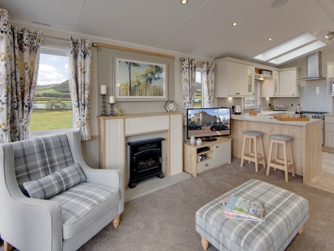

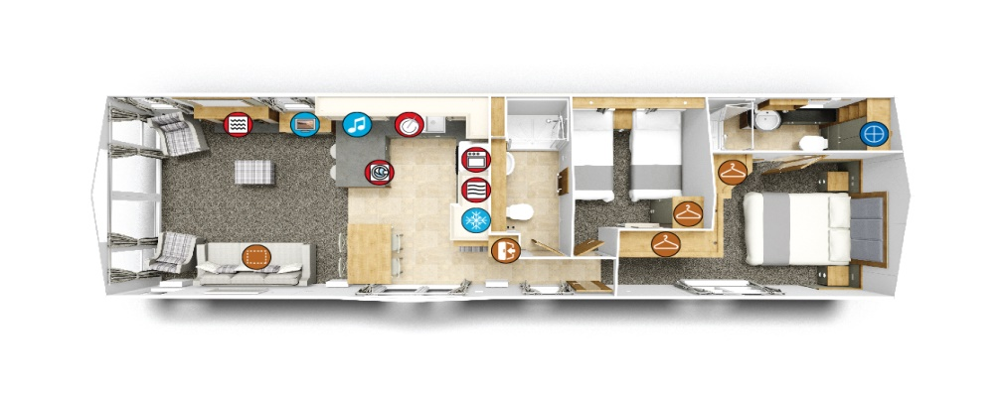
There are currently 3 Willerby Vogue, 19, 21 and 22. The Vogue Holiday Homes are approximately 120m from the Reception. Each of the Vogue Holiday Homes has wooden decking with 3 steps up to Vogue Holiday Home 22 and 4 steps up to Vogue Holiday Homes 19 & 21. There is ample parking for a family car adjacent to each Holiday Home. The following details are the same for each of the Vogue Holiday Homes:
- The entrance door has an opening width of 0.745m with a green double glazed door with a full length toughened glass panel and black handle at a height of 1.00m.
- You then enter into an open plan Kitchen/Dinning/Lounge area.
- The Kitchen worktops are 0.91m high with Cupboards, a fridge/freezer, dishwasher, washing dryer and oven and grill built in below it. A gas hob sits at the same height as the worktops. The Microwave is positioned approximately 0.5m above the worktop in a separate housing as are the wall mounted kitchen cupboards.
- Internally all the cupboard and door handles are a contrasting colour to make them stand out.
- All the chrome/black finished light switches are at a height of 1.3m and the electrical outlets are either just above the worktops in the kitchen or at a height of 0.26m throughout the rest of the Holiday Home.
- In the Lounge there are Patio Doors, which open to a width of 1.70m out onto the decking. Internally the handles and doors are white; externally the door is green with black handles. The TV is on a low cabinet in the lounge.
- From the Kitchen there is a Hallway with a width of 0.64m leading to 2 bedrooms and a family shower room. There is a small seat with coat hooks above it, with a tall storage cupboard next to it.
- The Family Shower Room door has an opening width of 0.51m and leads into a modern design room consisting of a standard W/C and Wash Basin and a shower cubicle measuring 1.00m x 0.73m. The cubicle door is of a bi-folding design and has an opening width of 0.75m.
- The twin bedroom has a door opening width of 0.50m and contains 2 x 3’ wide single beds, a small bedside cabinet and a large single wardrobe with 2 x drawers below.
- The Main Bedroom has a door opening of 0.56m and contains a King-size bed with bedside cabinets and wall mounted TV. There is a double wardrobe with 6 drawers and shelving as well as a single wardrobe. There is an en-suite with a standard W/C, washbasin and a shower cubicle. The shower cubicle has an opening width of 0.56m. There is a vanity unit in the Main Bedroom at a height of 0.79m with knee room below it.
- All the floor coverings are a contrasting colour to the walls.

Portland Lodge

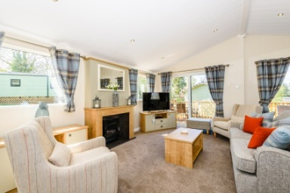

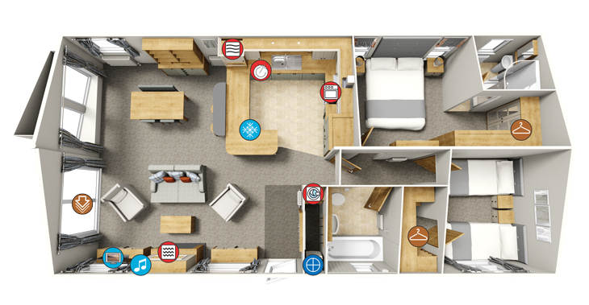
The Portland Lodge is situated approximately 100m uphill from the Reception. It is easily accessible with no step onto the wooden decking area. The parking area is to the right-hand side of the lodge at the rear. The decking area is across the front of the Lodge and extends down to the rear past the side door.
• The entrance door is of green UPVc construction with a toughened glass full length panel and an opening width of 0.73m. The handle is contrasting black and is 1.04m off the decking.
• You enter into a very modern style open plan kitchen/diner/lounge area with flush fitting ceiling lights. There is an area inside the doorway that has a heavy-duty grey carpet. The remainder of the lounge / dining area has a brown/beige carpet covering the floor. On the right as you enter the Portland is a utility room incorporating a washer dryer, the boiler and 4 coat hooks.
• The Lounge contains 1 sofa, 2 contrasting high back chairs and a foot stool. The TV in on a low cabinet. There is an electric fire with fire surround. To the right of the fire surround is a control unit for the Bluetooth MP3 system (0.87m). The TV is situated on a low level TV unit also to the right of the fire surround.
• There is a sliding patio door on the front of the Lodge with an opening of 0.76m.
• The dining area contains a large light oak effect table and 4 chairs.
• The kitchen has oak effect worktops at 0.9m high with cupboards, dishwasher and an integrated fridge freezer below. The microwave is housed 0.20m above the worktop with the wall cupboards at 0.45m above the worktops. There is a stainless steel sink set into the worktop. A gas hob sits at the same height as the worktops. The cupboard doors have a cream matt finish with chrome handles. The floor is covered with tile effect Lino.
• All the light switches are at a height of 1.39m and the electrical sockets are 0.15m off the floor (except in the kitchen, where they are situated .015m above the work surface).
• Off the kitchen there is a 0.57m wide doorway leading to the hallway. The hallway leads to the family bathroom with overhead shower and the 3 bedrooms. All the doors are a light wooden effect with contrasting chrome handles at a height of 0.88m except the hallway door which has 4 toughened obscure glass panels.
• The Main Bedroom has a door opening of 0.66m and contains a King-size bed. At the bottom of the bed is a wall mounted TV at a height of 1.82m, next to a vanity mirror and a single electric socket. There are 3 double wardrobes and 2 bedside units in the main bedroom. The en-suite (0.57m opening) includes a standard W/C, washbasin and a curved shower with an opening width of 0.43m. The shower head height is adjustable.
• The twin bedroom has 2 x 3’ single beds, a walk in wardrobe and bedside units.

The Laundry

The Laundry is situated within the main Holiday Home area of the Park and is approximately 200m from the Touring/Motorhome/PODs. The building is slightly elevated and is served by 2 x steps to the front and a small (1m) ramp to the left hand side. The entrance door is of a White UPVc construction with a white handle and a 0.1m step at the bottom. The opening width is 0.83m. Internally the floor is covered with a contrasting linoleum covering and has the following appliances:
- 2 x coin operated washers. 1.0m to the coin slot, 0.6m to the centre of the door opening.
- 2 x coin operated dryers. 1.0m to the coin slot, 0.6m to the centre of the door opening.
- 1 x freestanding height adjustable Ironing Board.
- 1 x Coin operated Iron (1.4m to the coin slot).
- 1 x Hand washing sink @ 0.86m high with knee room below.

Additional Information

All our Accommodations come with Smoke Detectors, CO2 Detectors and all are centrally heated.

There is a modern play area for children on the site with all the equipment conforming to the current regulations.
A Fire Risk Assessment has been undertaken in line with the current regulations. Fire Assembly points are clearly signed and positioned away from buildings, and a Fire Action plan is displayed at each Fire assembly point and in Reception. The policy and procedures for Fire Safety and Fire Fighting equipment are regularly monitored by the Staff and Park Owners.

Customer care is a fundamental part of training for all our Staff as well as disability awareness and Health and Safety.

Assistance dogs can be accommodated in the designated pet friendly lodges/holiday homes.

The reception for mobile phones is very good. Wi-Fi connection and usage is included within the Hire Charges for each accommodation unit.

